**C: @ Qiong:**

**- to generate the cluster you used just WT gene expression data right ?**

**- please check for consistency to avoid mistakes**

Ivan: These are only WT data. Qiong can you please double check?

**D: @ Qiong/Ivan:**

**- are the numbers still valid ?**

Ivan: I am only aware of one WT data analysis and this never changed.

**E,F,G: @ Qiong/Ivan:**

**- in E the go terms....is this just a GREAT analysis from the published CHIP seq or does it link/include to the gene expression data from wild type sampes from us as well ?**

Ivan: The great analysis is based on 500 top Hnf6 ChIP-Seq peaks. There is no use of exp. data here.

**- is the Figure order ok or should current D be in front of current G ?**

Ivan: I am fine in the order (C – only WT expression, D,E,F WT chip-seq and G chip-seq with WT exp). I would not change unless it do not fit the text flow.

**- is it necessary to have the HNF6 de novo motif in the main figure ?**

Ivan: I think the motif can stay in the supplement. This is only a “quality check”. Anyway you should refeer in the text that most peaks have a characteristic Hnf6 motif.

**- F it´s GATA6 right not GATA2 ?**

Ivan: The experiments are based on Gata6:

<http://www.ebi.ac.uk/arrayexpress/experiments/E-MTAB-1990/samples/>

**- G....can we mark significance level....does it correspond to a certain Z-score ?**

Ivan: Z-score of 2/-2 is a uncorrected p-value of 0.01. Here is a proposal based on the corrected p-value. In this case, we canstate that absolute z-scores > 2.2 have a signifincate of 0.05 p-value. In this case the only significant values are V- ESC/DE and I - ES genes are depleted of Hnf6 peaks with 2.18e-005 and 0.0018. VIII - DE/PE/PP/BC and IX - PE/PP/BC groups are enriched with Hnf6 peaks 0.0028 and 3.18E-007. Here is an example on how this can be displayed graphically. It is possibly best to implement this directly in acrobat.

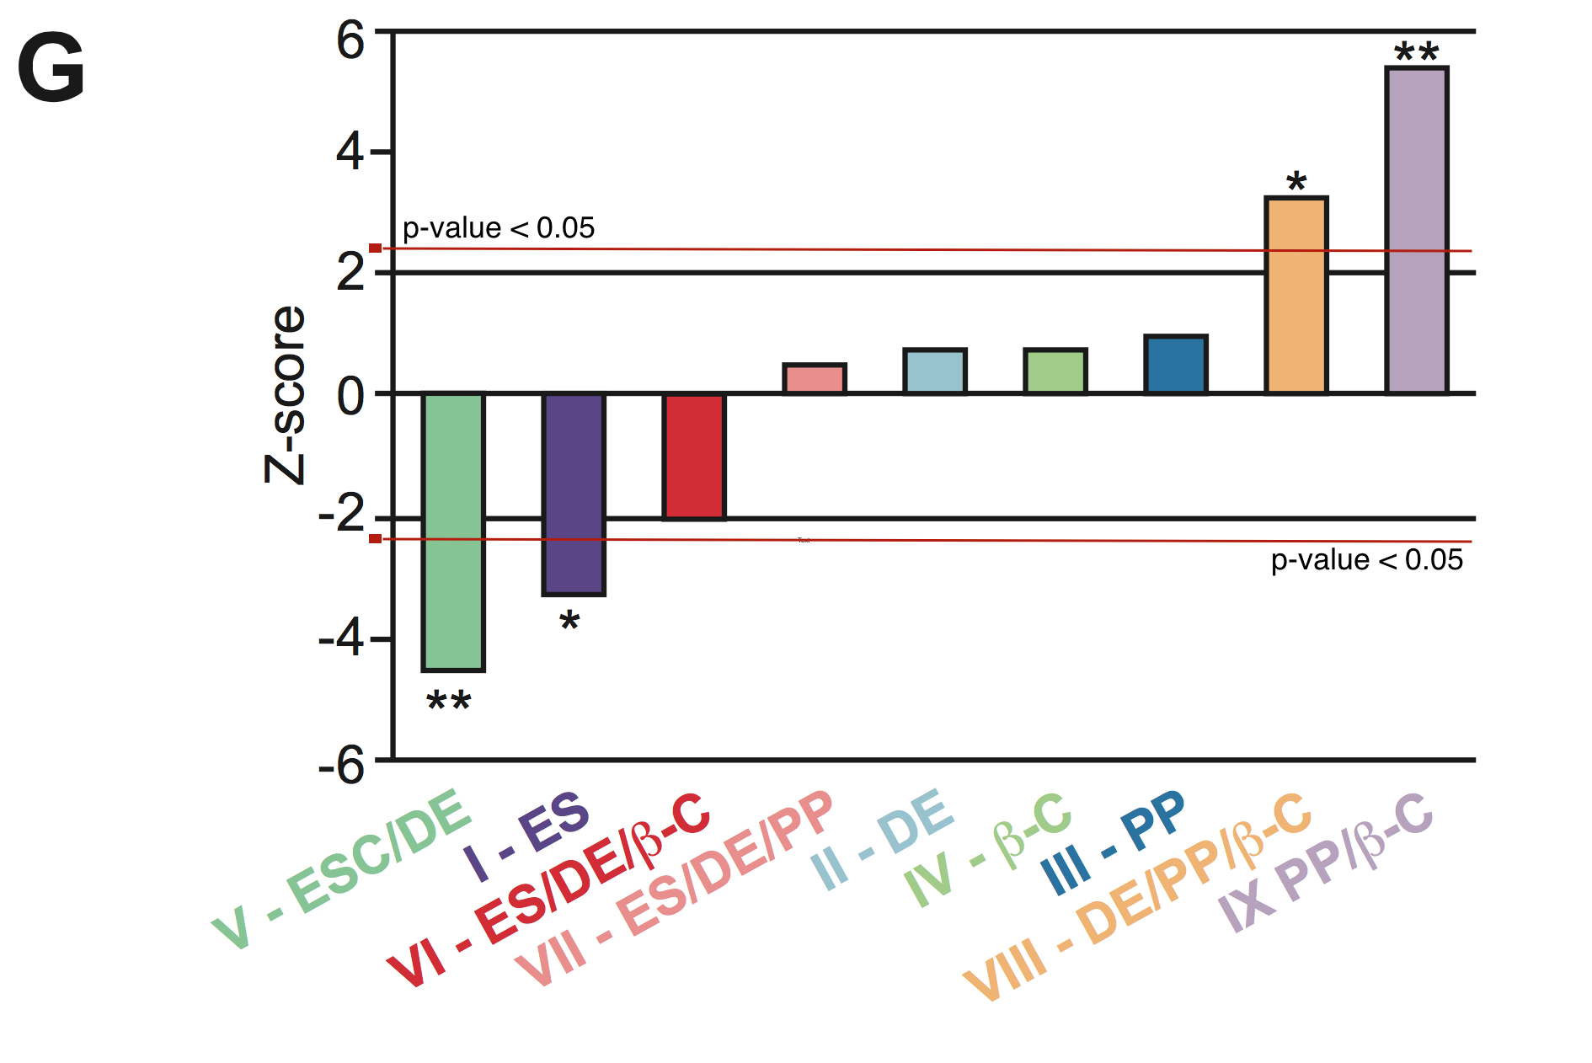

**I,J: @ Qiong/Ivan:**

**- the GO terms....do we just refer to the "down regulated" in mutants genes or do we use just WT vs. HOM or is the intersection of HET/HOM vs. WT ? Please specify?**

Ivan: My understanding was that we used WT vs. HET and HOM. Samples. Qiong, can you confirm this?

**We need to provide illustration in Ven diagramms and heat maps in the supplement....why did the heat maps show different numbers of clones ?**

Ivan: Some clones were left out of the analys and they differ from the PP1 and PP2. Right now I cannot see which condition refeers to figure 4C and D. Qiong, can you include these? Here is the list of clones qiong previously reported to have removed (ES_Hom_96_d0_1, ES_Het_82_d0_2, DE_WT_d4_2, PP1_Hom_126_d10_1, PP1_Hom_126_d10_2, PP2_Hom_126_d14_1, PP2_Hom_126_d14_2, and BC_WT_d25_3) .

**M: Ivan:**

* **I think I will skip the beta cells...could you please send me the graph again with significance line inside and w/o beta cell information ?**

Ivan: Sure. Here it is an example. I am sending an excell table and pdf figures named figure2M. Here, the z-score for adjusted p-value of 0.05 is a bit higher (absolute value of 2.3). The p-values of significant groups are: under representation of genes down regulated in WT vs. Het. (0.008848616) and Hom. (0.03886514) in PE stage. Overrepresentation fo genes up regulated in PE (WT vs. Het. 5.44E-005; WT vs. Hom. 5.54E-005) and PP (WT vs. Het. 9.76E-011; WT vs. Hom. 9.76 E-011).

**@ suppl figure 1:**

**B: @ Ivan**

* **What do the numbers in brackets mean ?**

Ivan: This is the proportion of the top scoring peaks (500) that have a binding site of that motif. One note, one peak can have more than one motif.

**C: @ Ivan**

* **Please provide me high resolution screen shots with the following order of genes in two rows, the current ones are stuffer and will be replaced afterwards:**
  + **First row: HNF6, Pdx1, Foxa2**
  + **Second row: Nkx6.1, Nkx6.2, Nkx2.2**

Ivan: They are in att (see files SupFig1c)

**@ suppl figure 4:**

**A: @ Qiong/Ivan/Anett:**

* **Honestly speaking I am still not satisfied with the illustration as it is intuitive to recognise the major claim. Maybe 3D in a cube ? Or circling the stages ? Drawing in directions ? I am not sure and need additional help…but it remains not intuitive enough but important enough to be included….please ensure that the clones being in this part are the ones which have been used for analysis throughout as I remember that we have kicked some out as well…..I mean at PE we have 2(WT)-2(HET)-4(HOM) and at PP 2-4-4 ? Didn´t we have more here ? no choice to make this more conclusive ?**

Ivan: I don't like the color coding of the picture. I would rather color distinct stages with the same color. I am also proposing some drawings. Open to discussion. The major trend is on the PE/PP cells. Note also that the PCA changed now, I am not using BC cells. I have send some proposals names

Here are the samples used in the PCA.

ES Samples

2x WT – ES_WT_d0_1, ES_WT_d0_2

4X Het - ES_Het_374_d0_1, ES_Het_374_d0_2, ES_Het_82_d0_1, ES_Het_82_d0_2.2

4x Hom - ES_Hom_120_d0_1, ES_Hom_120_d0_2, ES_Hom_126_d0_1 ES_Hom_126_d0_2

DE Samples

1x WT - DE_WT_d4_1

5x Het – DE_Het_374_d4_1, DE_Het_374_d4_2, DE_Het_82_d4_1, DE_Het_82_d4_1.2, DE_Het_82_d4_2

6x Hom – DE_Hom_120_d4_1, DE_Hom_120_d4_2, DE_Hom_126_d4_1, DE_Hom_126_d4_2, DE_Hom_96_d4_1, DE_Hom_96_d4_2s

PP1/PE samples

2x WT - "PP1_WT_d10_1" "PP1_WT_d10_2"

2x Het - "PP1_Het_82_d10_1" "PP1_Het_82_d10_2"

4x Hom - PP1_Hom_120_d10_1, PP1_Hom_120_d10_2, PP1_Hom_96_d10_1, PP1_Hom_96_d10_2

PP2/PP Samples

2x WT – "PP2_WT_d14_1", "PP2_WT_d14_2"

4x Het. - PP2_Het_374_d14_1, PP2_Het_374_d14_2, PP2_Het_82_d14_1, PP2_Het_82_d14_2

3x Hom. - PP2_Hom_120_d14_1, PP2_Hom_120_d14_2, PP2_Hom_96_d14_1, PP2_Hom_96_d14_2

**B: @ Qiong/Ivan:**

* **A dendrogramm ?**

Ivan: One can give a try, but this might not work since the distinct stages are far apart and will cluster together. Qiong, can you do this?

**C @ Qiong (also refers to Ivan/Anett)**

* **Please provide nicer ven diagrams with more illustrative colors (maybe similar colors as in E).** 
  + **Why do the heat maps in C and D have different numbers ?** 
    - **I think this needs to be adjusted to get the most conclusive results being illustrative but still scientifically rigorous…I mean same samples all the time…I think it´s puzzling to have sometimes this many and then this many clones at various differentiation stages.**
* **Provide high res heat maps for Figure**

Ivan: We had to remove some of the samples for quality reasons (see before).